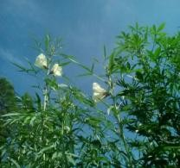
ZHANGPU ZHONGLONG KENAF SEEDS CO.,LTD |  | Mobile: 0086-15695966658  Mobile: 0086 18959620286  TEL:0086 596 3215898  Email: cnkenafseed@gmail.com
Address: No.140, Dongsheng Road,Shuian town,Zhangpu County,Fujian province, China
Address in Chinese: 福建省漳浦县绥安镇东胜路 140 号

COMMERICAN INVOICE OF ZL-7 DECORTICATOR
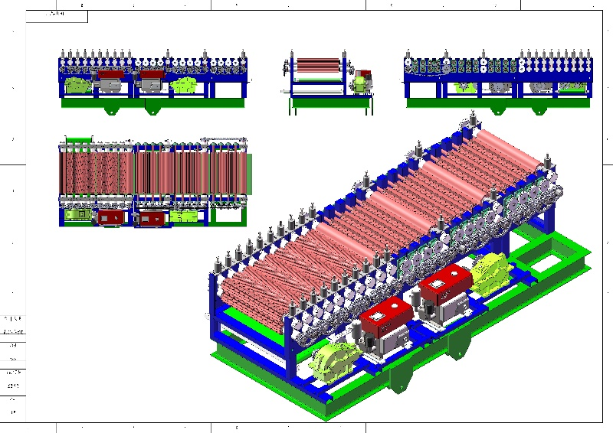 |  | Bank : CHINA CONSTRUCTION BANK CORP ZHANGZHOU BR.  A/C: ZHANGPU ZHONGLONG KENAF SEEDS CO.,LTD  A/C No. :35050166730700000014 SWIFT CODE：PCBCCNBJFJZ  Intermediary Bank: BANK OF AMERICA,NEW YORK(BOFAUS3N )  CHINA CONSTRUCTION BANK HONGKONG BR.(SWIFT :PCBCHKHH)  JP MORGAN CHASE BANK N.A.NEW  YORK(SWIFT:CHASUS33)
Name:. | Description |  | Quantity |  | Unit  price | Amount
ZL-7 KENAF FIBER DECORTICATION MACHINE | SIZE:1.5 METERS WIDE  6 METERS LONG，1.4 METERS HIGH WITH DIESEL ENGINE TO WORK IN THE FIELD .  Weight 6 TONS  60 rollers in 30 group  Procession speed: 800-1000kilos raw materials per one hour  Function:The front part of rollers will break the hard stalk and the further rollers with increased rolling speed to make the decortication of fiber and hurd ,inpurity control within 1% and the convey belt at the machine bottom to send the hurds out . |  | Each 1 Unit |  | $17800 | $17800
Totally 12000KILO | With Freight to Klang Port,Malaysia via Sea Freight
 |  |  |  | TOTAL |  | $17800

